Converse Antonyms

✅ What is Converses (Subtype of Relational Antonyms)
# Source: AI Source: Provided by: [Data Path: Persons Table -> ID Column: 1, Name_En Column: Motasem Essam] -> From: [Chatgpt (GPT-4-turbo)] on [7/30/2025]
Converses are a specific subtype of relational antonyms where two terms describe the same relationship from opposite perspectives. The existence of one logically implies the existence of the other.

🔎 Definition:
# Source: AI Source: Provided by: [Data Path: Persons Table -> ID Column: 1, Name_En Column: Motasem Essam] -> From: [Chatgpt (GPT-4-turbo)] on [7/30/2025]
Converses are antonym pairs that represent reciprocal roles or perspectives in a relationship — if one exists, the other must as well.

📌 Key Features:
# Source: AI Source: Provided by: [Data Path: Persons Table -> ID Column: 1, Name_En Column: Motasem Essam] -> From: [Chatgpt (GPT-4-turbo)] on [7/30/2025]
- Involves bidirectional relationships
- Switching the subject and object maintains the truth of the sentence
- Often involve roles, transactions, or positions

🔁 Examples:
# Source: AI Source: Provided by: [Data Path: Persons Table -> ID Column: 1, Name_En Column: Motasem Essam] -> From: [Chatgpt (GPT-4-turbo)] on [7/30/2025]
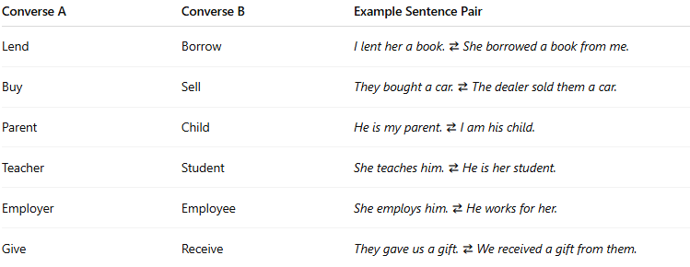
Converse A | Converse B | Example Sentence Pair
Lend | Borrow | I lent her a book. ⇄ She borrowed a book from me.
Buy | Sell | They bought a car. ⇄ The dealer sold them a car.
Parent | Child | He is my parent. ⇄ I am his child.
Teacher | Student | She teaches him. ⇄ He is her student.
Employer | Employee | She employs him. ⇄ He works for her.
Give | Receive | They gave us a gift. ⇄ We received a gift from them.

🧠 Compare with General Relational Antonyms:
# Source: AI Source: Provided by: [Data Path: Persons Table -> ID Column: 1, Name_En Column: Motasem Essam] -> From: [Chatgpt (GPT-4-turbo)] on [7/30/2025]
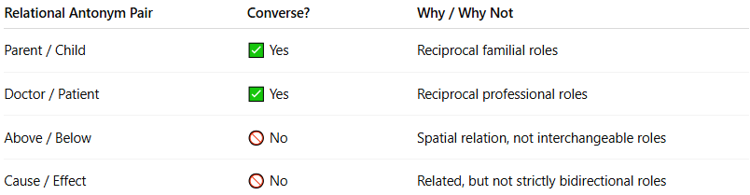
Relational Antonym Pair | Converse? | Why / Why Not
Parent / Child | ✅ Yes | Reciprocal familial roles
Doctor / Patient | ✅ Yes | Reciprocal professional roles
Above / Below | 🚫 No | Spatial relation, not interchangeable roles
Cause / Effect | 🚫 No | Related, but not strictly bidirectional roles

Relational antonyms vs Converses antonyms

🔍 Detailed Comparison Table:
# Source: AI Source: Provided by: [Data Path: Persons Table -> ID Column: 1, Name_En Column: Motasem Essam] -> From: [Chatgpt (GPT-4-turbo)] on [7/30/2025]
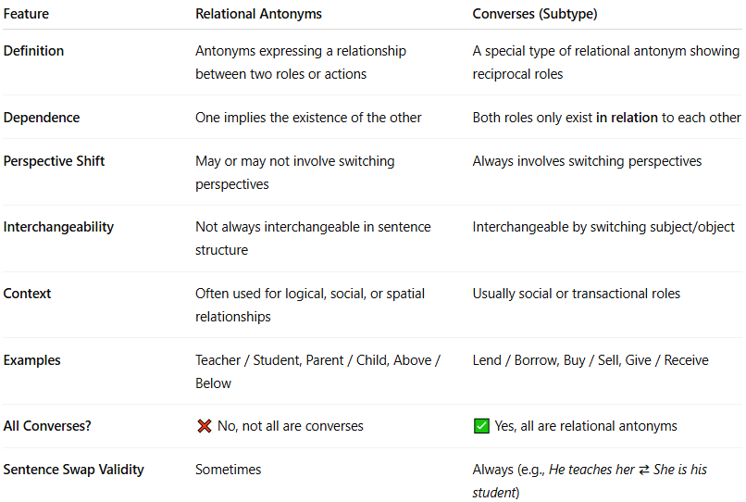
Feature | Relational Antonyms | Converses (Subtype)
Definition | Antonyms expressing a relationship between two roles or actions | A special type of relational antonym showing reciprocal roles
Dependence | One implies the existence of the other | Both roles only exist in relation to each other
Perspective Shift | May or may not involve switching perspectives | Always involves switching perspectives
Interchangeability | Not always interchangeable in sentence structure | Interchangeable by switching subject/object
Context | Often used for logical, social, or spatial relationships | Usually social or transactional roles
Examples | Teacher / Student, Parent / Child, Above / Below | Lend / Borrow, Buy / Sell, Give / Receive
All Converses? | ❌ No, not all are converses | ✅ Yes, all are relational antonyms
Sentence Swap Validity | Sometimes | Always (e.g., He teaches her ⇄ She is his student)

✅ Examples to Distinguish:
# Source: AI Source: Provided by: [Data Path: Persons Table -> ID Column: 1, Name_En Column: Motasem Essam] -> From: [Chatgpt (GPT-4-turbo)] on [7/30/2025]
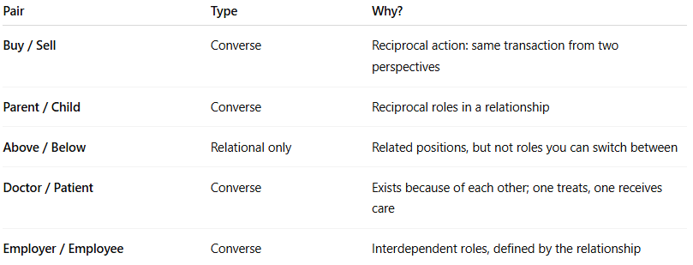
Pair | Type | Why?
Buy / Sell | Converse | Reciprocal action: same transaction from two perspectives
Parent / Child | Converse | Reciprocal roles in a relationship
Above / Below | Relational only | Related positions, but not roles you can switch between
Doctor / Patient | Converse | Exists because of each other; one treats, one receives care
Employer / Employee | Converse | Interdependent roles, defined by the relationship

🔁 Quick Mnemonic:
# Source: AI Source: Provided by: [Data Path: Persons Table -> ID Column: 1, Name_En Column: Motasem Essam] -> From: [Chatgpt (GPT-4-turbo)] on [7/30/2025]
- Relational = related roles or positions
- Converses = "flip" the sentence — it still makes sense!

🧠 Summary:
# Source: AI Source: Provided by: [Data Path: Persons Table -> ID Column: 1, Name_En Column: Motasem Essam] -> From: [Chatgpt (GPT-4-turbo)] on [7/30/2025]
✅ All Converses are Relational Antonyms,
❌ But not all Relational Antonyms are Converses.

✅ Summary:
# Source: AI Source: Provided by: [Data Path: Persons Table -> ID Column: 1, Name_En Column: Motasem Essam] -> From: [Chatgpt (GPT-4-turbo)] on [7/30/2025]
Converses are relational antonyms where perspective-switching defines the contrast.
They’re common in social, transactional, or positional relationships.

